|  |
| --- |
| Circle Language Spec: Inheritance |

## System Command Extension By Shadowing

You can accomplish command extension by employing the shadowing concept. The idea is that you shadow the base command, executing your own procedure and call the base command from your own procedure.

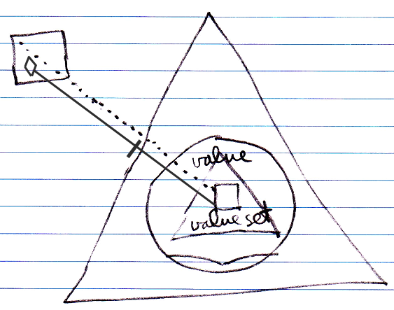

Note that the call to the base command has to be qualified with the base object.

When anyone tries to call Value Set, the shadowing command is run instead, unless someone can qualify the call with the base object.

A benefit of system command extension by shadowing compared to normal system command extension is that these extensions only count inside the derived class.